Project Planning Phase
Project Planning Template (Product Backlog, Sprint Planning, Stories, Story points)

Date | 27 June 2025
Team ID | LTVIP2025TMID59821
Project Name | Pattern Sense: Classifying Fabric Patterns using Deep Learning
Maximum Marks | 5 Marks

Product Backlog, Sprint Schedule, and Estimation (4 Marks)
Sprint | Functional Requirement (Epic) | User Story Number | User Story / Task | Story Points | Priority | Team Members
Sprint-1 | Dataset Setup and Preprocessing | USN-1 | As a developer, I want to collect, clean, and preprocess the dataset to prepare for training. | 3 | High | Ram, Usha
Sprint-1 | Transfer Learning Implementation | USN-2 | As a model trainer, I want to apply ResNet50 and custom CNNs to train on pattern data. | 3 | High | Ram, Prasanna
Sprint-2 | Model Evaluation & Tuning | USN-3 | As a developer, I want to improve accuracy through augmentation and parameter tuning. | 3 | High | Ram, Prem Kumar
Sprint-2 | Model Prediction System | USN-4 | As a user, I want to upload a pattern image and get predictions with confidence score. | 2 | High | Prasanna. Prem Kumar
Sprint-3 | Web App Integration using Flask |  |  | 3 | Medium | Usha, Prasanna
  USN-5
  As a user, I want to interact with the model via a simple Flask web interface.
 |  |  |  | 2 | Low | Ram, Usha, Prem Kumar
  Sprint-3
  Image Enhancement for Better Input Quality
  USN-6
  As a user, I want to enhance image quality before prediction for better results.

Project Tracker, Velocity & Burndown Chart: (4 Marks)
Sprint | Total Story Points | Duration | Sprint Start Date | Sprint End Date (Planned) | Story Points Completed (as on Planned End Date) | Sprint Release Date (Actual)
Sprint-1 | 20 | 6 Days | 9-Jun-2025 | 14-Jun-2025 | 20 | 9-Jun-2025
Sprint-2 | 20 | 6 Days | 16-Jun-2025 | 21-Jun-2025 | 20 | 16-Jun-2025
Sprint-3 | 20 | 6 Days | 23-Jun-2025 | 28-Jun-2025 | 20 | 25-Jun-2025

Velocity:
Imagine we have a 10-day sprint duration, and the velocity of the team is 20 (points per sprint). Let’s calculate the team’s average velocity (AV) per iteration unit (story points per day)
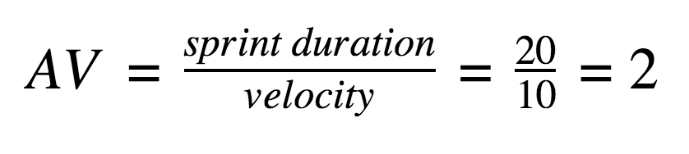

Burndown Chart:
A burn down chart is a graphical representation of work left to do versus time. It is often used in agile software development methodologies such as Scrum. However, burn down charts can be applied to any project containing measurable progress over time.
it shows:
- X-axis → Time (Sprint days)
- Y-axis → Story points (Effort remaining)
- The ideal line shows how progress should go.
- The actual line shows your real progress.

https://www.visual-paradigm.com/scrum/scrum-burndown-chart/
https://www.atlassian.com/agile/tutorials/burndown-charts

Reference:
https://www.atlassian.com/agile/project-management
https://www.atlassian.com/agile/tutorials/how-to-do-scrum-with-jira-software
https://www.atlassian.com/agile/tutorials/epics
https://www.atlassian.com/agile/tutorials/sprints
https://www.atlassian.com/agile/project-management/estimation
https://www.atlassian.com/agile/tutorials/burndown-charts

